AeP IT Management App: Progress

I summarized the data that needs to be stored and displayed for each page in the app, and as a way of keeping track of it we put it in tables that will be used as a preliminary method of display in the app while we develop a more user friendly interface.

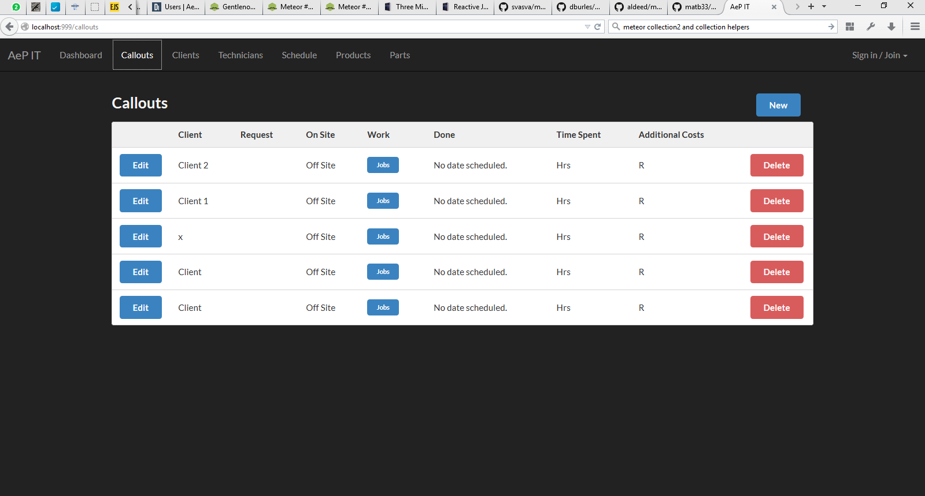  
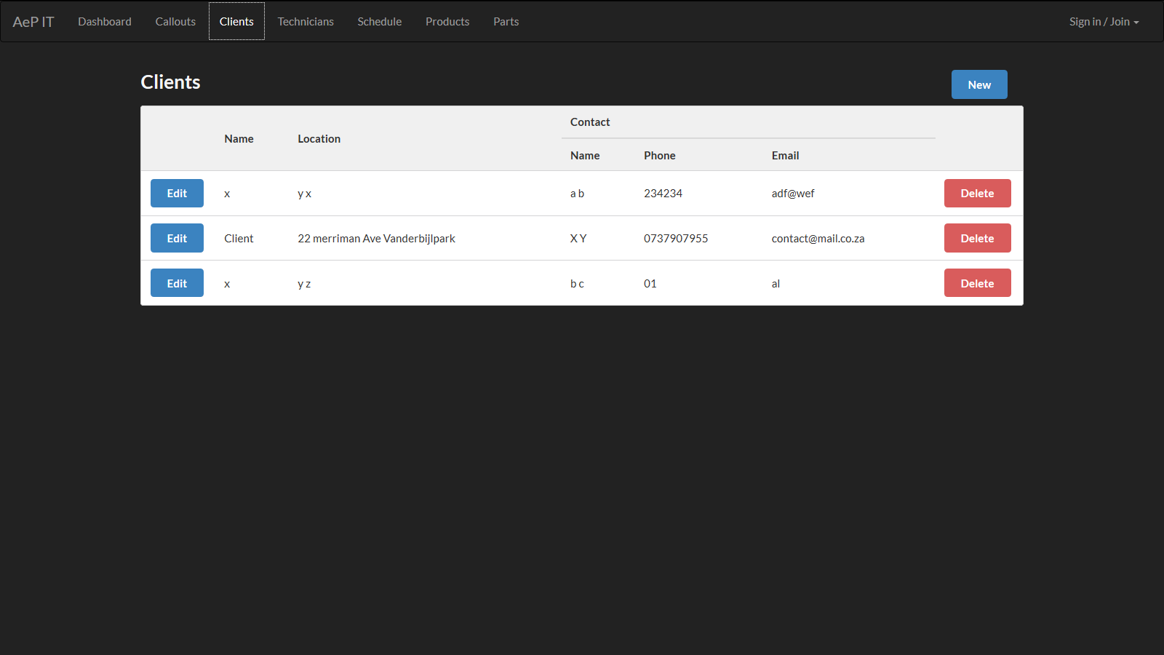

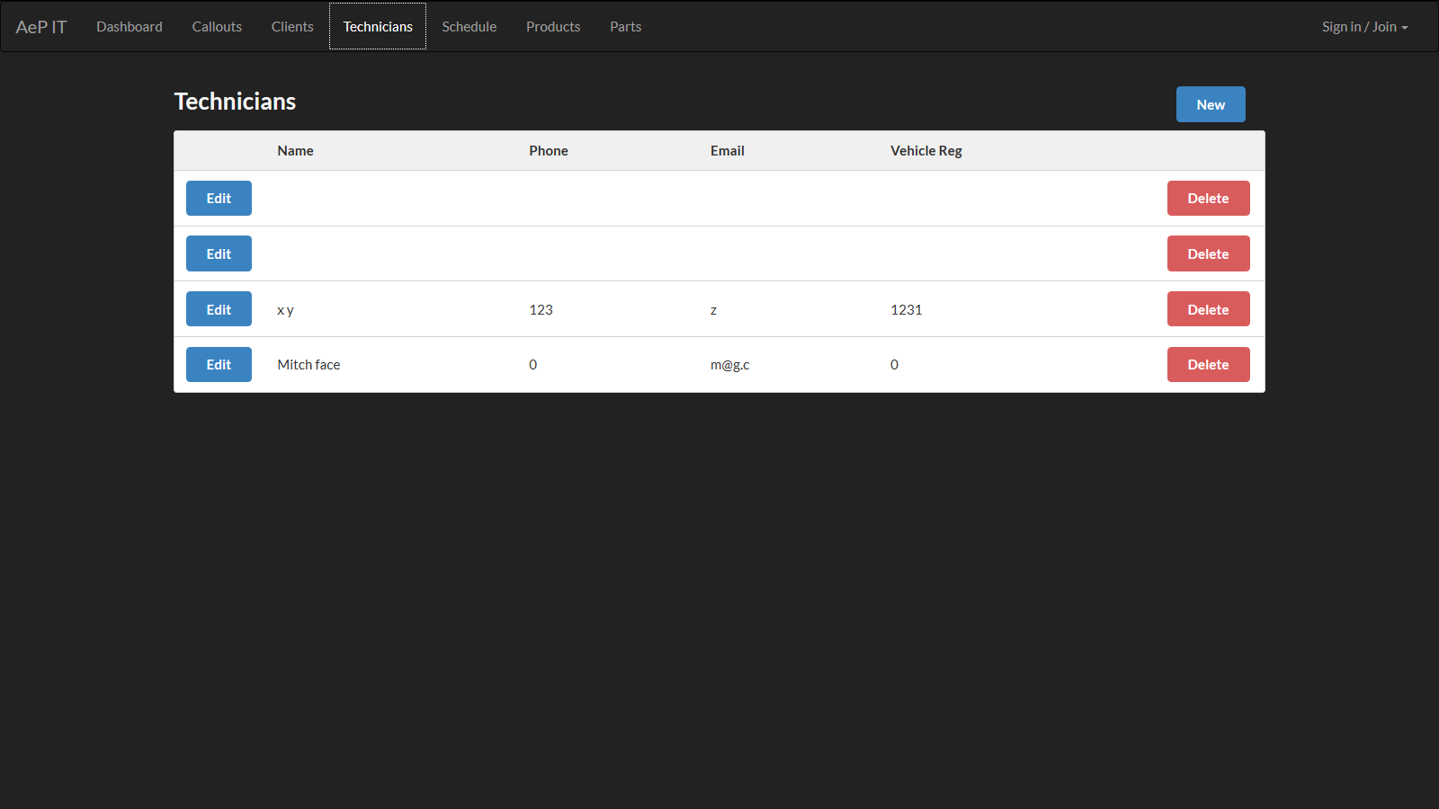

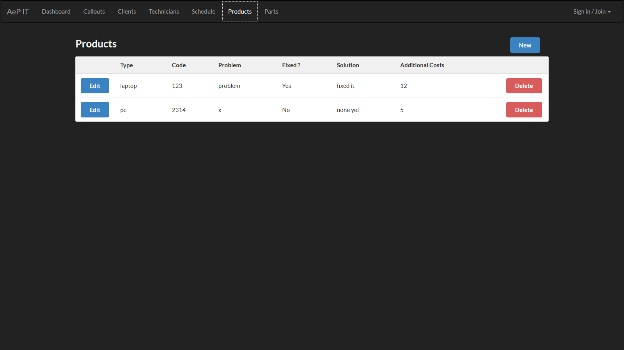

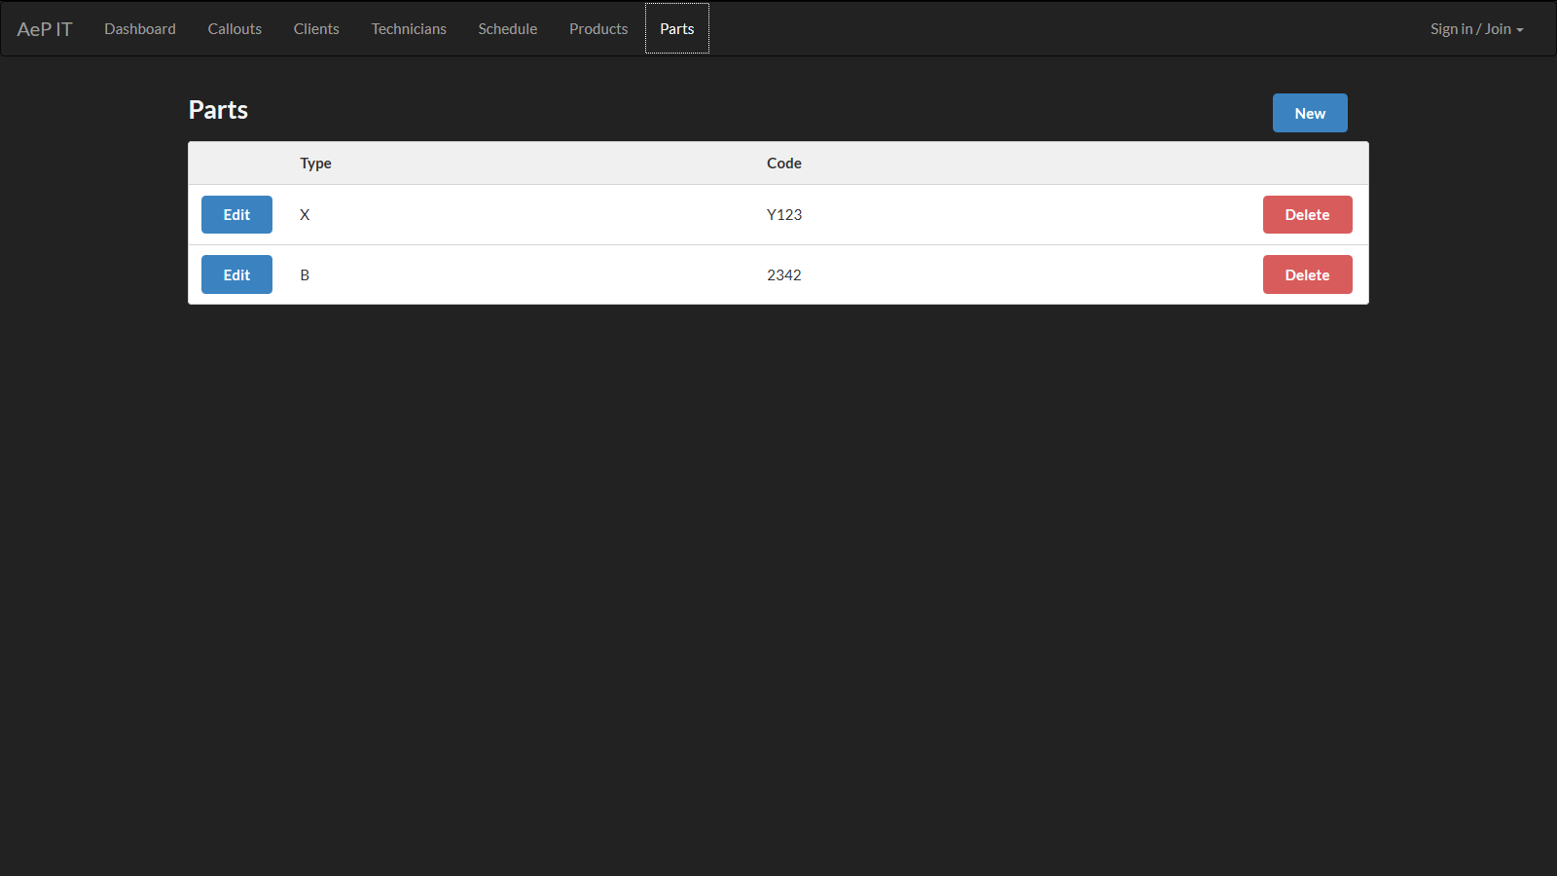

The next step was to decide on the permissions system for the app (which users should see/change which information) and so far the user system consists of

1. An admin user who controls user information and registers new managers and technicians

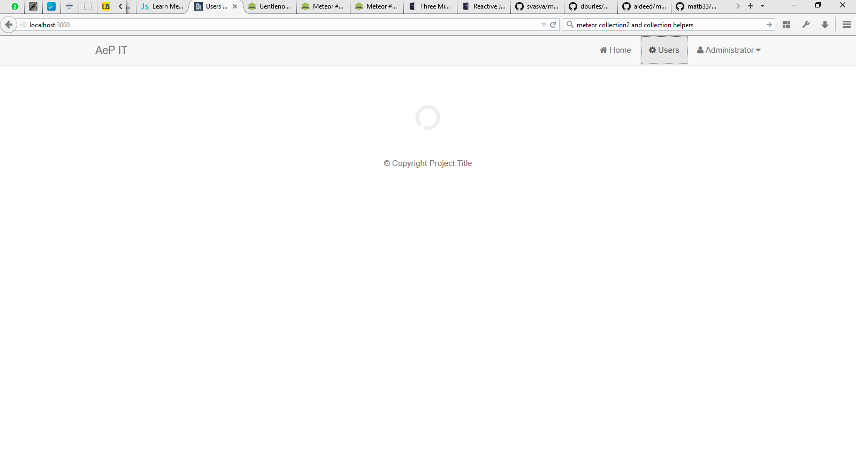

1. A group of ‘manager’ users who can create new clients, add new callouts from clients, and assign work to technicians at a scheduled date.

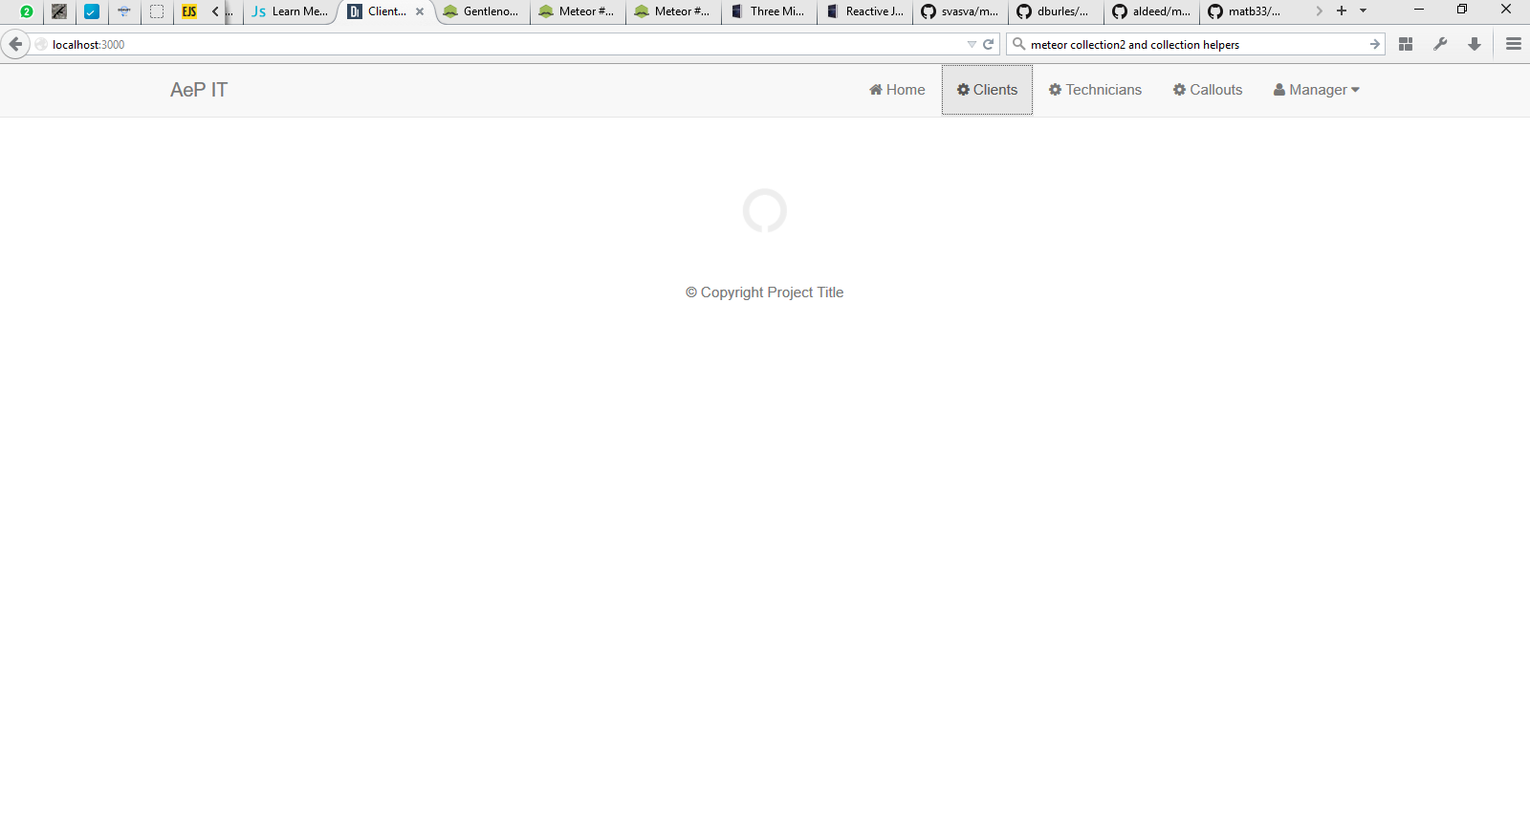

A technician who can view a schedule of work assigned to him and request to change dates if need be. They will also be able to indicate when work is done, how many hours it took and what products they fixed or how many extra parts are needed to fix the problem, and write any notes on additional costs involved. They will also be able to log in from their phone to see and change the schedule and work information.

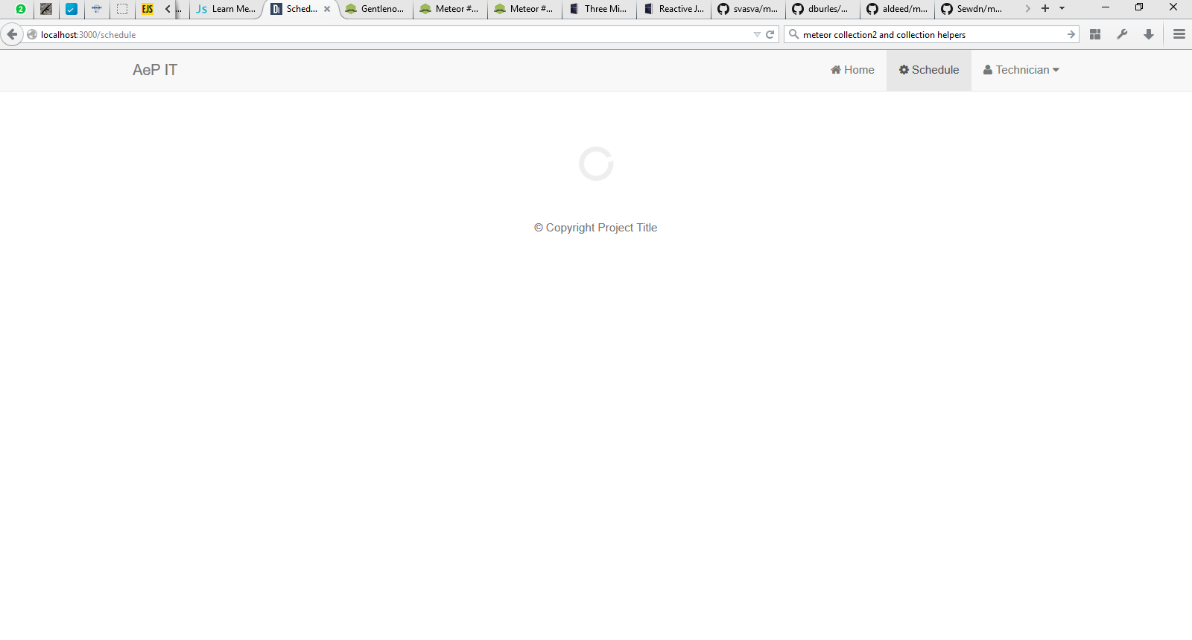

Email notifications will be incorporated for job completion and scheduled changes, and a signature field will be included on each job page for clients to sign when a technician has completed a job.